# Git HOL 1 - Output and Commands

This document contains the commands executed and the corresponding outputs for Git Hands-On Lab 1 (HOL 1). The outputs are based on the provided screenshots.

## Part 1: Git Configuration and Notepad++ Integration

Commands Executed:

* git config --global user.email ritam07mc@gmail.com
* git config --list
* notepad++
* git config --global core.editor "notepad++ -multiInst -nosession"
* git config --global -e

Output

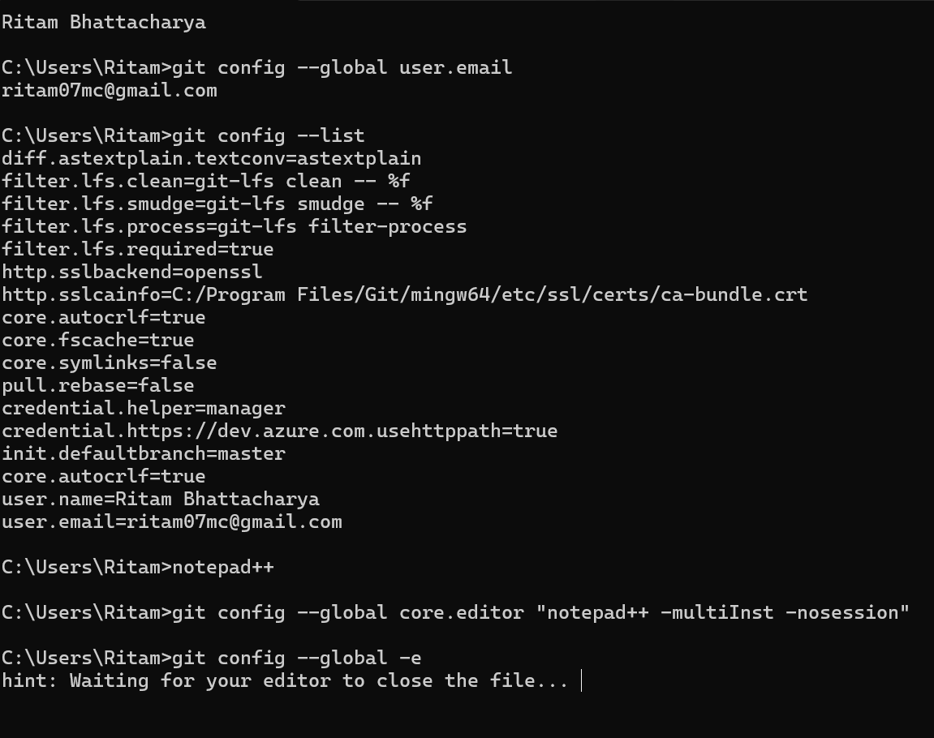

## Part 2: Git Initialization, File Creation, Commit, and Push

Commands Executed:

* mkdir GitDemo
* cd GitDemo
* git init
* echo "Welcome to Git" > welcome.txt
* cat welcome.txt
* git status
* git add welcome.txt
* git commit -m "Initial commit with welcome.txt"
* git remote add origin https://github.com/Ramben0909/GitDemo.git
* git push -u origin master

Output:

